Two Factor Authentication Voting System

In this project as per your requirements we have designed following modules

1. Admin module: admin can login to system using username and password as ‘admin and admin’. After login admin will add new party details along with symbols. Admin will add voter details by capturing information like AADHAR number, thumb image, email, phone number and then capture users photo. Admin can view all part details and can view vote count for each party
2. User Module: user can login to system by using username, AADHAR number and thumb image. If all this details matched then OTP will be forward to user registered mail. After OTP validation user will be forward for face capturing and recognition. Once face recognized then user will be forward to cast vote by displaying various parties. User can cast his vote to desired party.

To run project install PYTHON 3.7 and then install all packages for requirements file and then install MYSQL database and then copy content from ‘database.txt’ file and paste in MYSQL console to create database.

Now double click on run.bat file to start python server and get below page

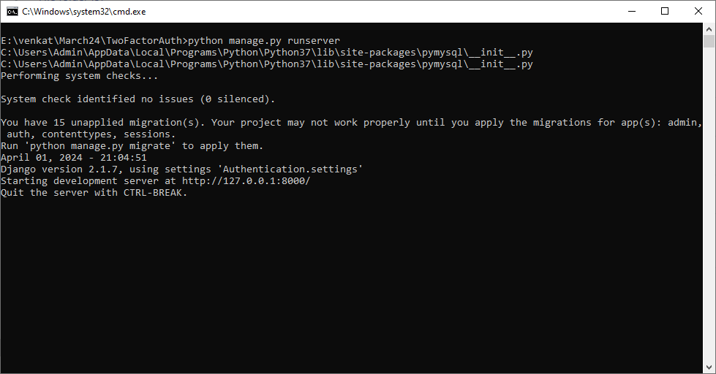

In above screen python server started and now open browser and enter URL as <http://127.0.0.1:8000/index.html> and press enter key to get below page

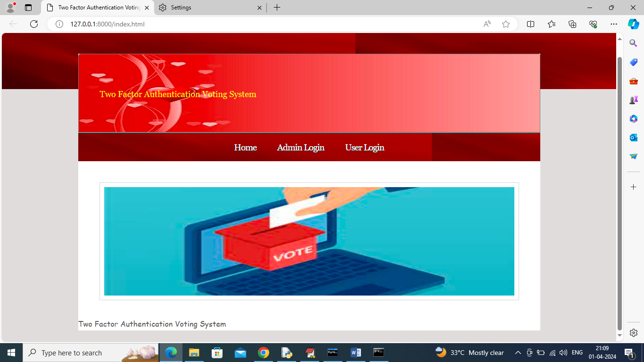

In above screen click on ‘Admin Login’ link to get below page

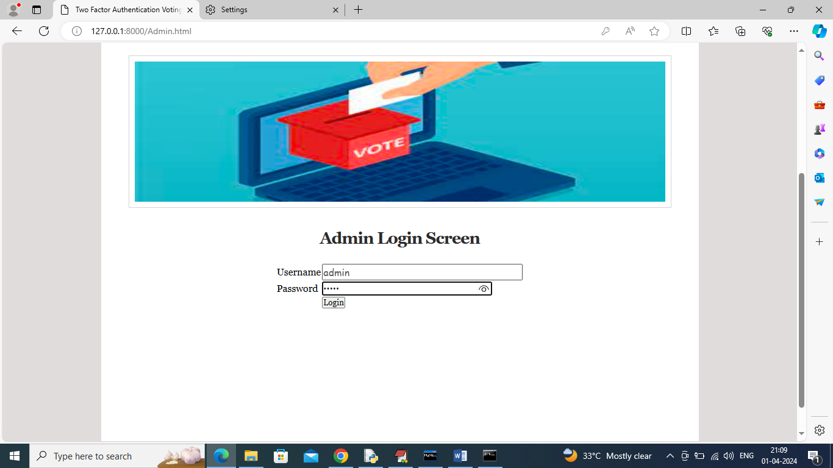

In above screen admin is login and after login will get below page

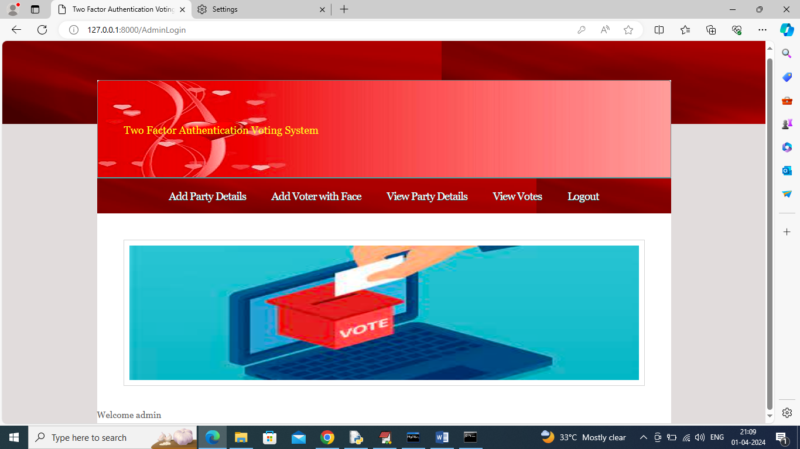

In above screen admin will click on ‘Add Party Details’ link to get below page

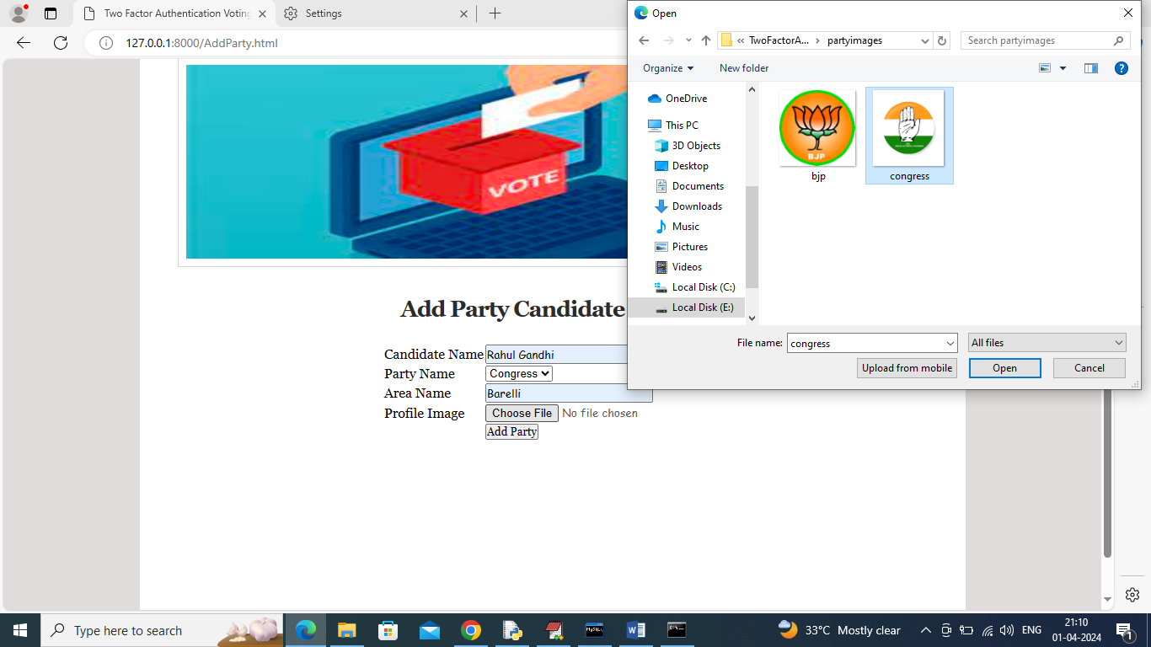

In above screen adding party candidate details along with party symbols and similarly you can add for any number of parties and now click on ‘Add Party’ button to get below page

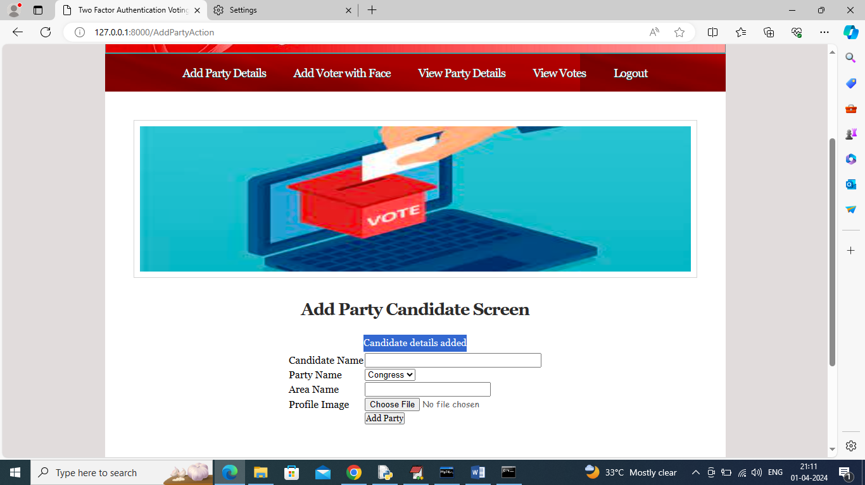

In above screen candidate details added and now click on ‘Add Voter with Face’ link to get below page

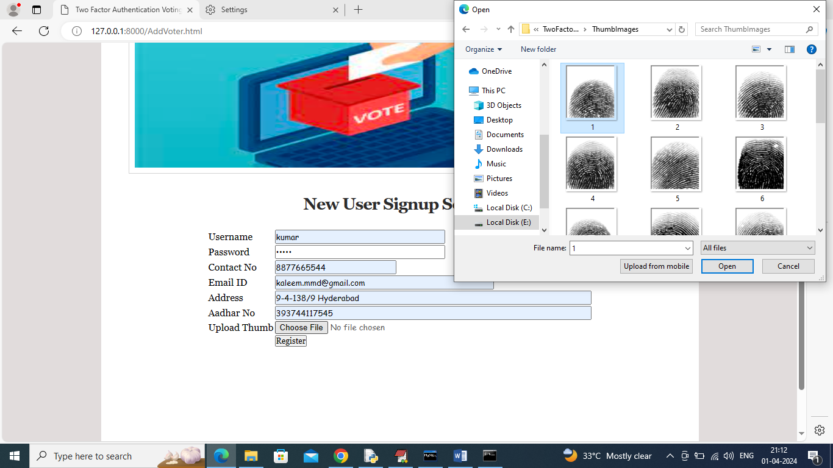

In above screen adding voter details along with username, AADHAR number, thumb image and give valid email to receive OTP and now click on ‘Register’ button to get below page

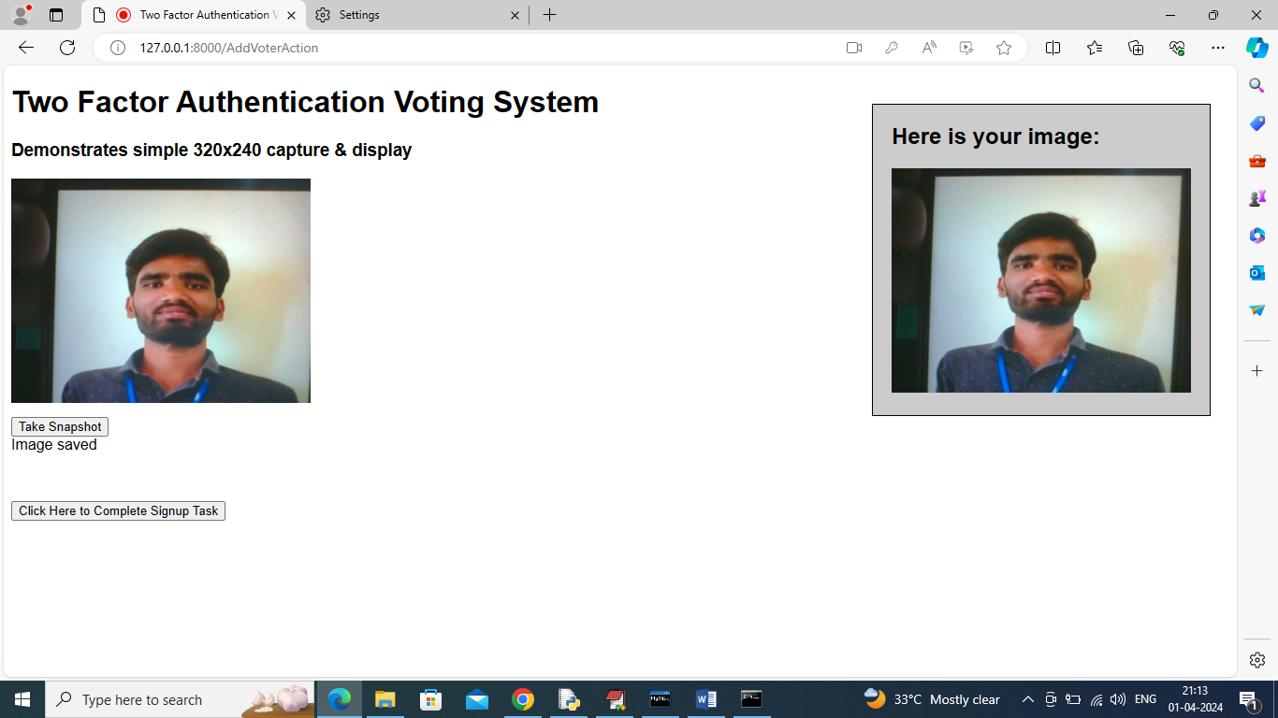

In above screen in left side webcam you can view face and then click on ‘Take Snapshot’ button to capture and preview face in right side panel and then click on ‘Click Here to Complete Sign up Task’ button to complete voter adding details and get below page



In above screen in blue colour text can see user with face, thumb and AADHAR details added to database. Similarly you can add any number of voters and now click on ‘View Party Details’ to view all existing party details like below page

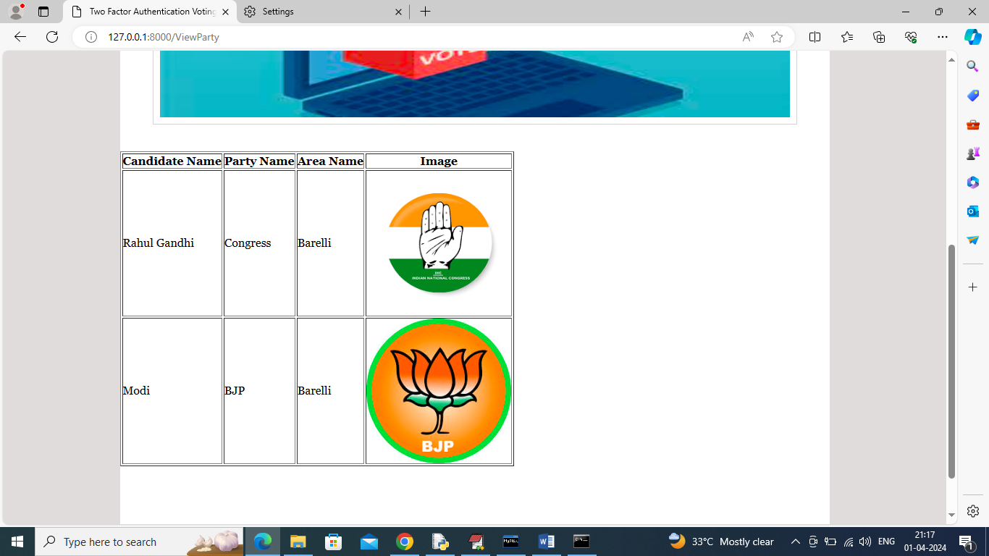

In above screen admin can view all added party candidate details and now logout and login as user to cast vote

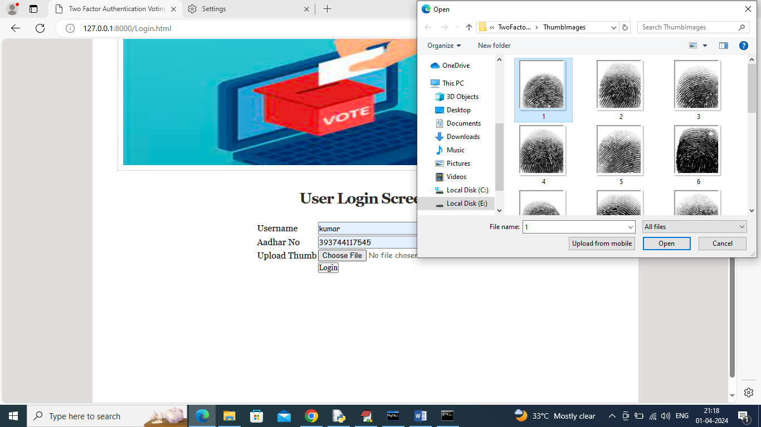

In above screen user is login with name, AADHAR and thumb image and then click on ‘Login’ button to get OTP in email

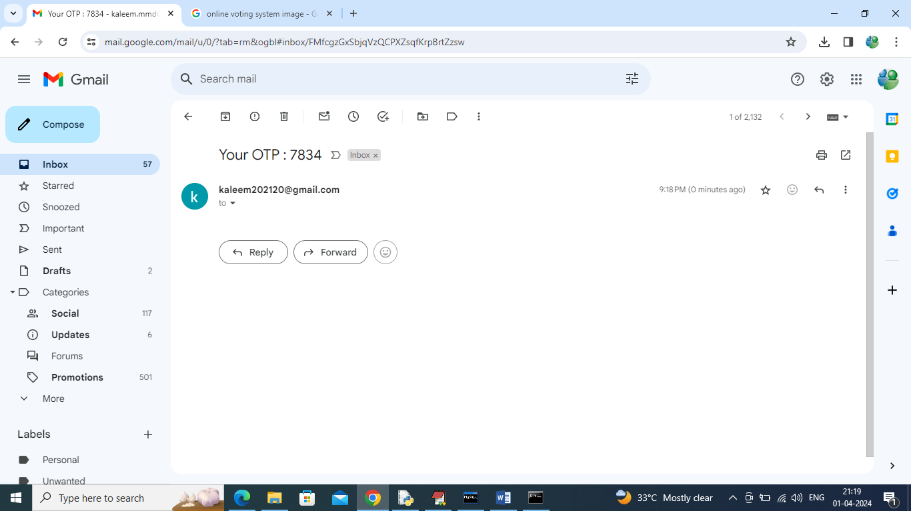

In above screen OTP received in email and then enter this OTP in application like below page

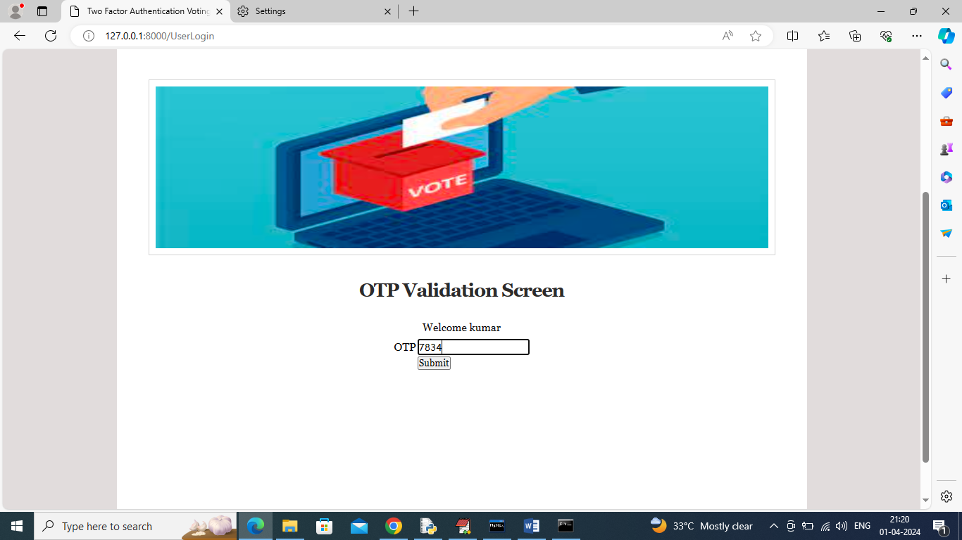

In above screen after entering OTP press button to get below page

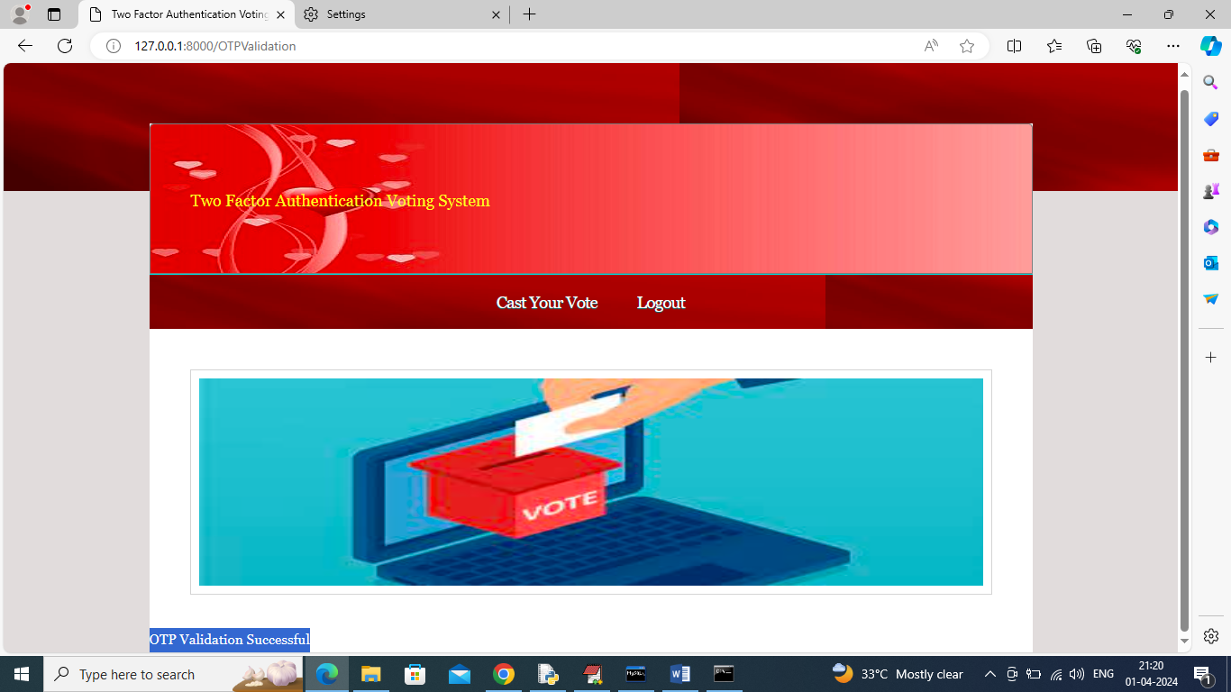

In above screen in blue text can see OTP validation successful and now click on ‘Cast Your Vote’ link to forward for face recognition and get below webcam

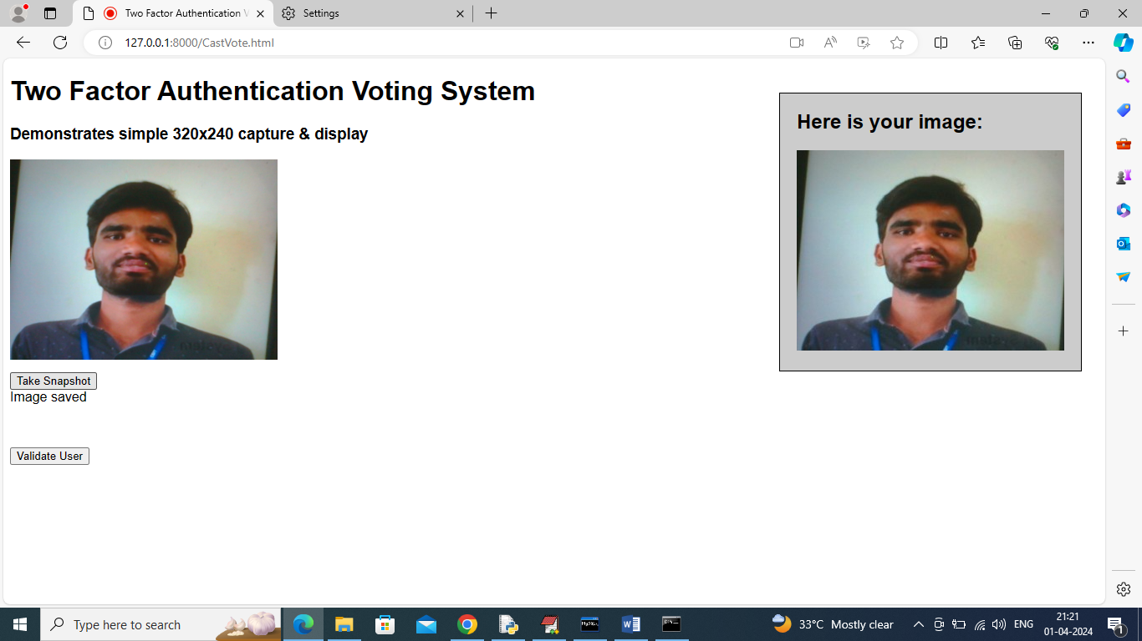

In above screen view face in webcam and then click on ‘Take Snapshot’ and then click on ‘Validate User’ button to recognized face and once recognition successful then will get below page

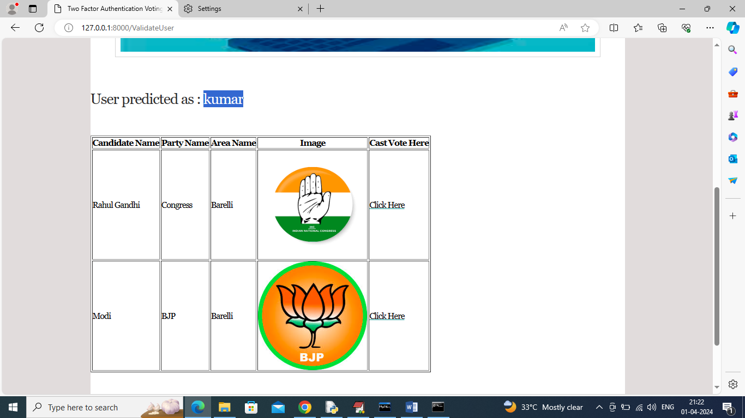

In above screen blue text can see user recognized as ‘kumar’ and now user can click on ‘Click Here’ link beside each candidate to cast his vote and then will get below page

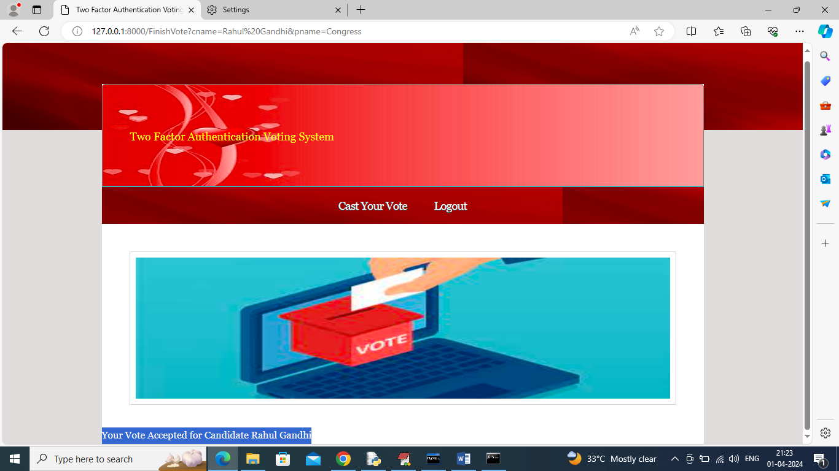

In above screen in blue text can see ‘Vote accepted for selected candidate’ and now logout and login as admin to view vote count

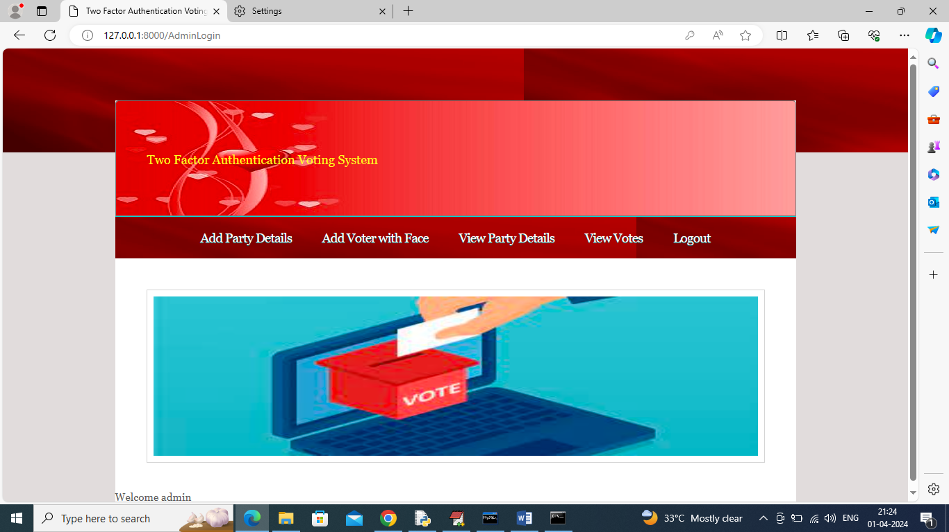

In above screen admin can click on ‘View Votes’ link to get below page

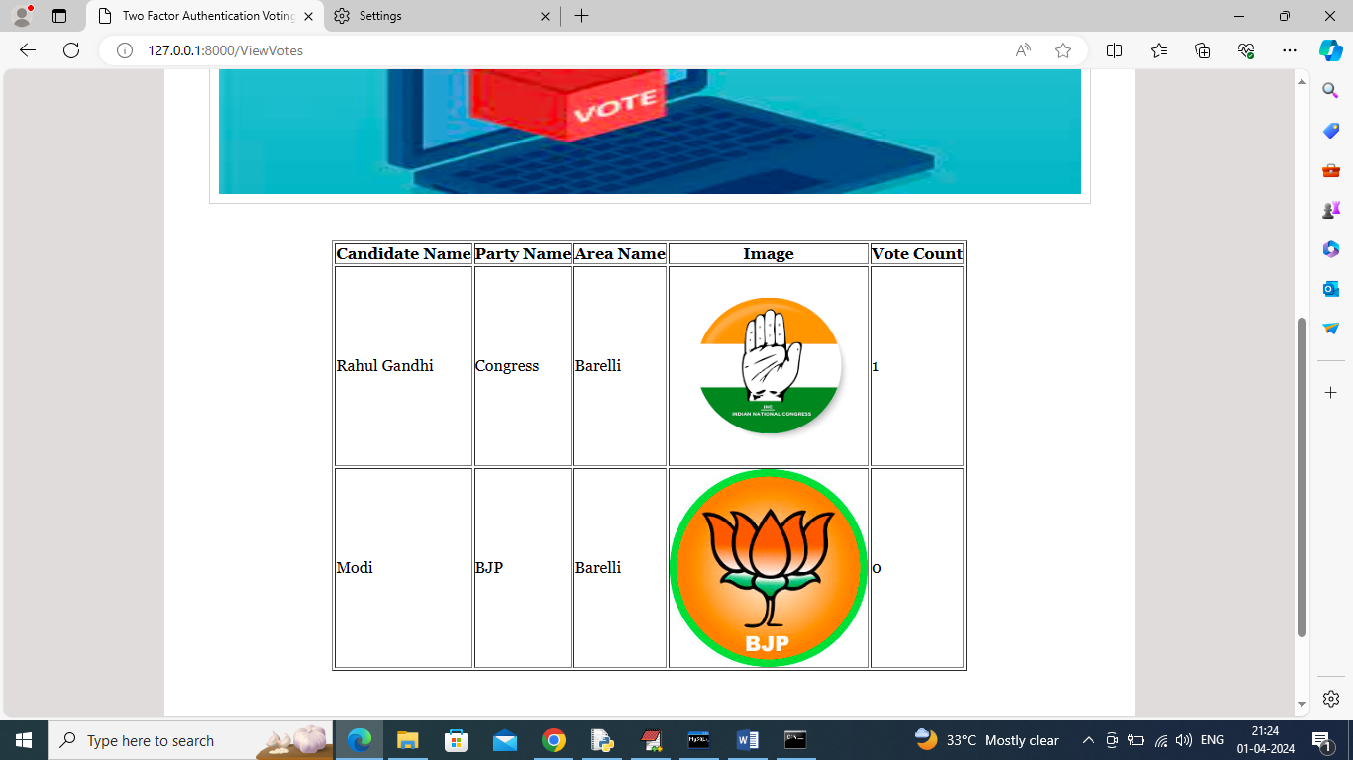

In above screen in last column admin can see which candidate got how many votes.

Similarly by following above screens you can cast vote to parties